**“Experiment 2.2”**

Student Name: **SUMIT KUMAR** UID: **20BCS8226**

Branch: **CSE** Section/Group: **808-A**

Semester: **5** Date of Submission: **28-10-22**

Subject Name: **Design and Analysis of Algorithms Lab** Subject Code: **20CSP-312**

1. **Aim/Overview of the practical:**

To implement a subset-sum problem using the dynamic programming.

**2. Task to be done/ Which logistics used:**

Write a program to find the subset-sum problem using the dynamic programming.

**3. Requirements (For programming-based labs):**

* Laptop or PC.
* Operation system (Mac, Windows, Linux, or any)
* Vs-Code with MinGw or any C++ Compiler

**4. Algorithm/Flowchart (For programming-based labs)**

1. First, it will divide the matrix sequence into two subsequences.
2. You will find the minimum cost of multiplying out each subsequence.
3. You will add these costs together and in the price of multiplying the two result matrices.
4. These procedures will be repeated for every possible matrix split and calculate the minimum.
5. **Steps for experiment/practical/Code:**

#include <iostream>

using namespace std;

int main()

{

    int n, sum;

    cin >> n >> sum;

    int a[n];

    for (int i = 0; i < n; i++)

        cin >> a[i];

    int table[n + 1][sum + 1];

    for (int i = 0; i < sum + 1; i++)

        table[0][i] = false;

    for (int i = 0; i < n + 1; i++)

        table[i][0] = true;

    for (int i = 1; i < n + 1; i++)

    {

        for (int j = 1; j < sum + 1; j++)

        {

            if (j < a[i - 1])

                table[i][j] = table[i - 1][j];

            else

                table[i][j] = table[i - 1][j] || table[i - 1][j - a[i - 1]];

        }

    }

    if (table[n][sum])

        cout << "Yes";

    else

        cout << "No";

}

**6. Output:**

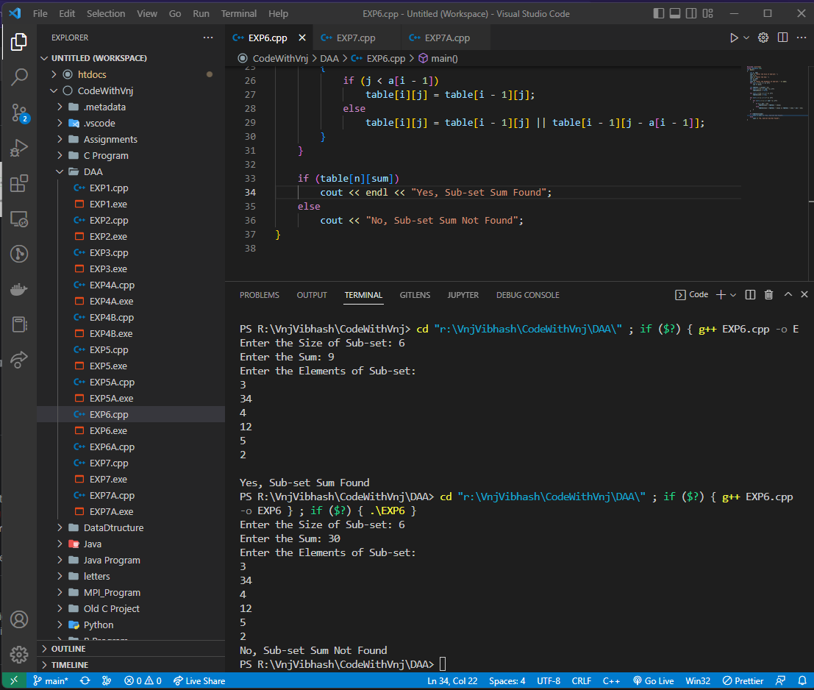

**Learning outcomes (What I have learnt):**

1. How to solve the sub-set sum problem using dynamic programming.
2. Learnt the real-life application of dynamic programming.

**Evaluation Grid (To be created per the faculty's SOP and Assessment guidelines):**

|  |  |  |  |
| --- | --- | --- | --- |
| Sr. No. | Parameters | Marks Obtained | Maximum Marks |
| 1. | Worksheet completion including writing learning objectives/Outcomes.  (To be submitted at the end of the day). |  |  |
| 2. | Post-Lab Quiz Result. |  |  |
| 3. | Student Engagement in  Simulation/Demonstration/Performance and Controls/Pre-Lab Questions. |  |  |
|  | Signature of Faculty (with Date): | Total Marks Obtained: |  |